**MZUMBE UNIVERSITY**



**FACULTY OF SCIENCE AND TECHNOLOGY**

**(FST)**

**COURSE CODE: CSS 062**

**COURSE: COMPUTER MAINTAINACE**

**PROGRAMME: DIT-1**

**TASK: GROUP ASSIGNMENT**

**LECTURE NAME: MATIKU KURIHO**

|  |  |  |
| --- | --- | --- |
| NO | NAME | REG. NUMBER |
| 1 |  |  |
| 2 |  |  |
| 3 |  |  |
| 4 |  |  |
| 5 |  |  |
| 6 |  |  |
| 7 |  |  |

1. Identify the problem with the computer/mobile phone (hardware or software)

* sound problem and installation of the window

The PC that we were given had this problem when you play a music or a video does not produce sound and also the user want us to install a new window

ii. mention any device used when applicable

* USB flash and external hard disk

1. Take snap shorts of all process you have gone through

STEP 1

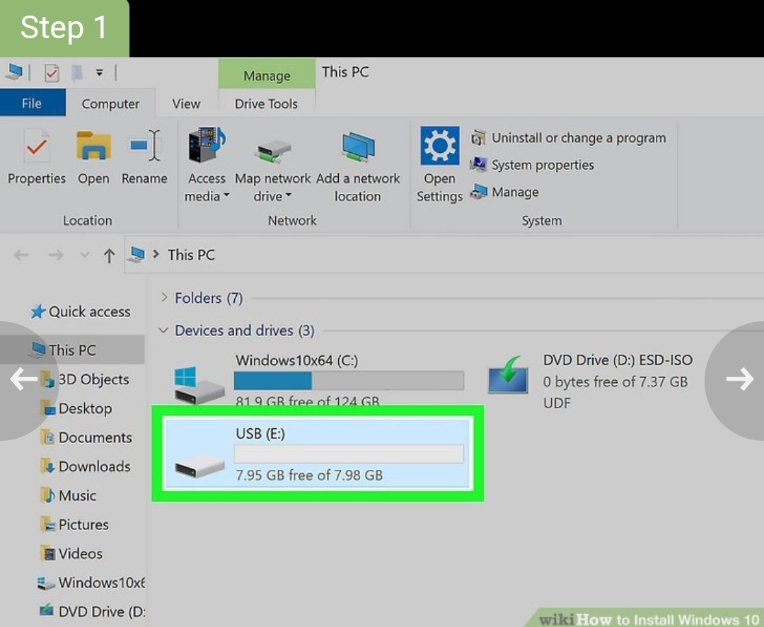

First you should ensure your PC meets the minimum windows 10 system requirements.

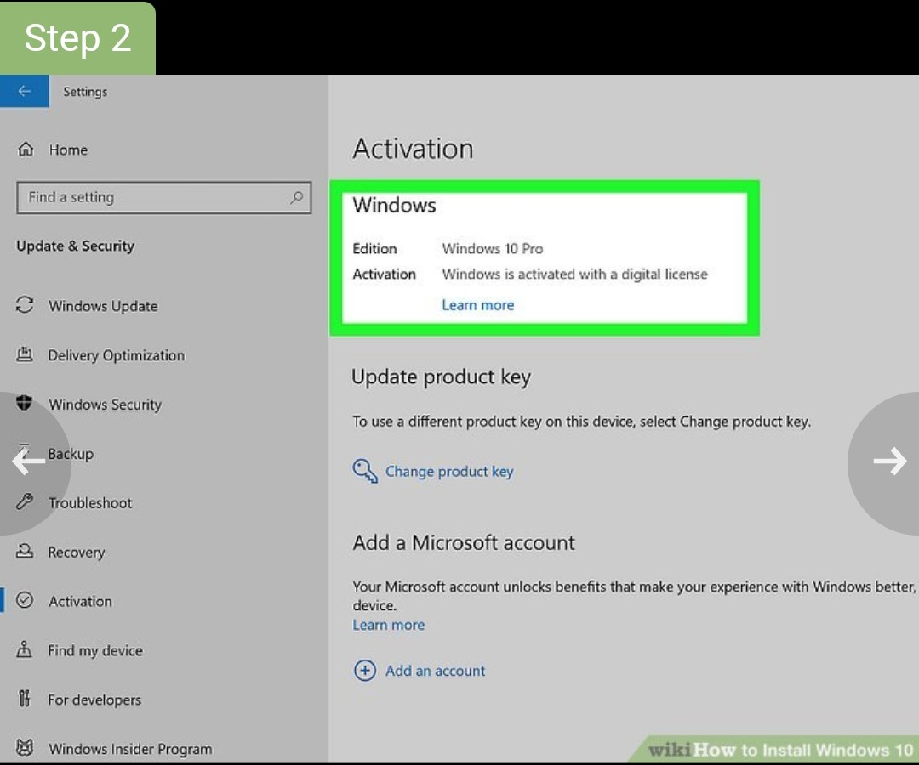

If your computer is not new, before starting the windows 10 installation process, it’s vital to back up your files.

STEP 3

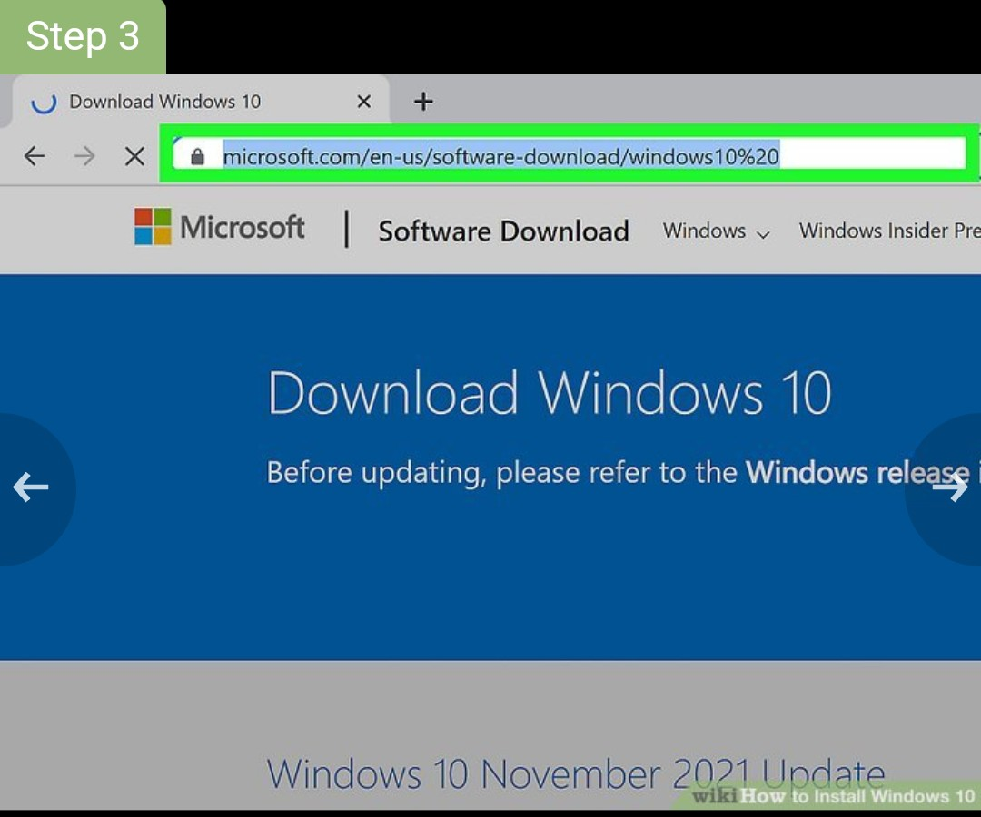

This time to go to windows 10 download page to download windows 10 ISO after you’ve verified it.

STEP 4

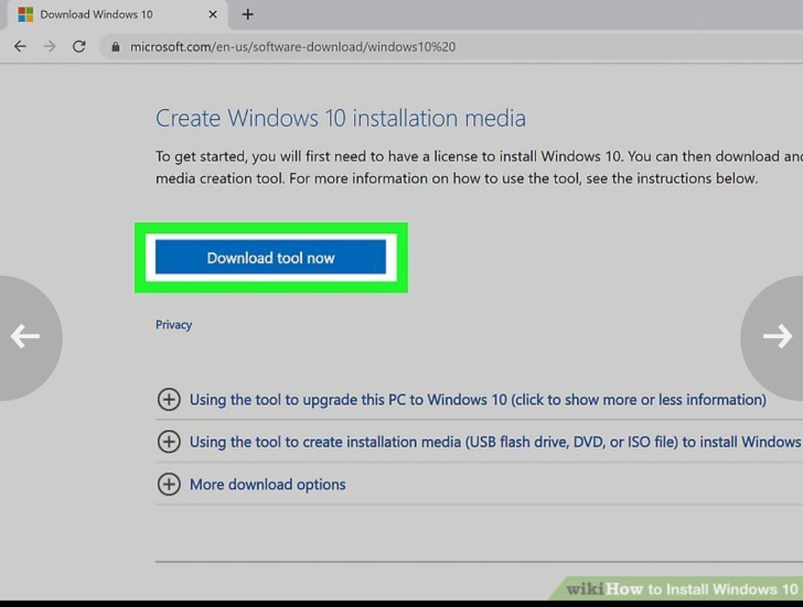

Insert the bootable USB drive into your computer and restart it.

STEP 5

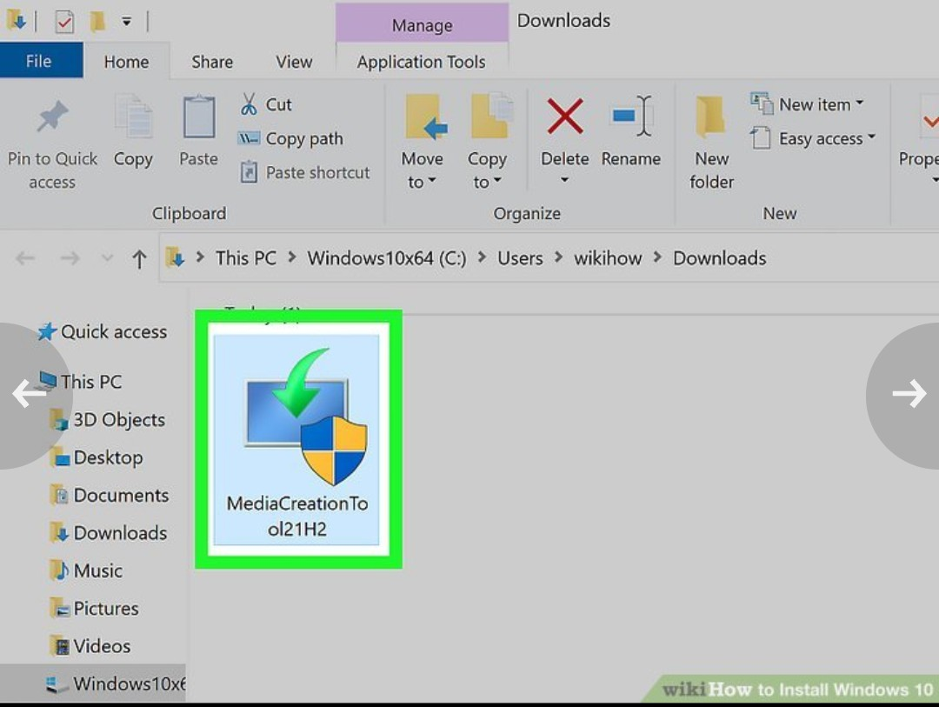

Select these parts: language to install, time and currency format, keyboard or input method.

STEP 6

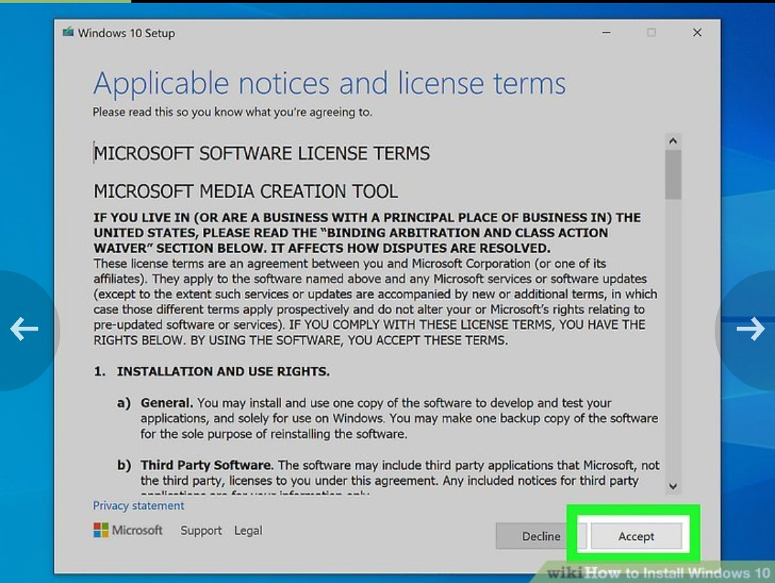

After window 10 has been installed you will be asked to customize your settings

STEP 7

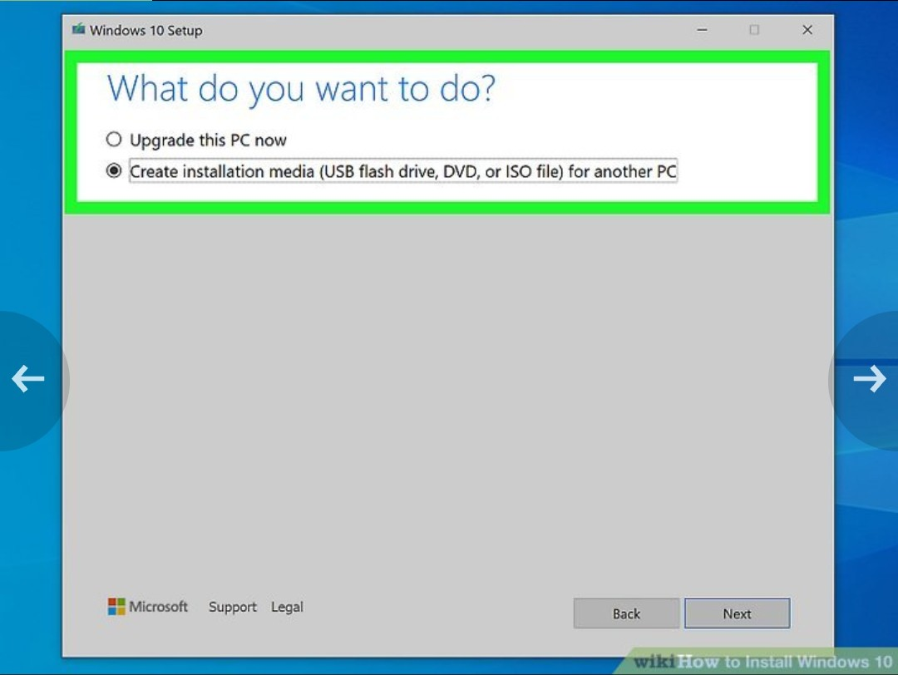

After customizing your personal settings, you should install any required drivers and software.

STEP 8

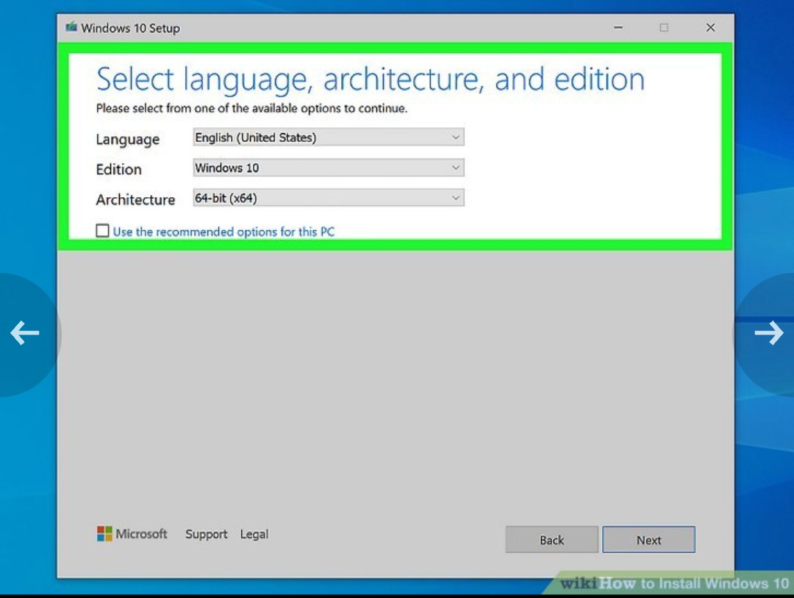

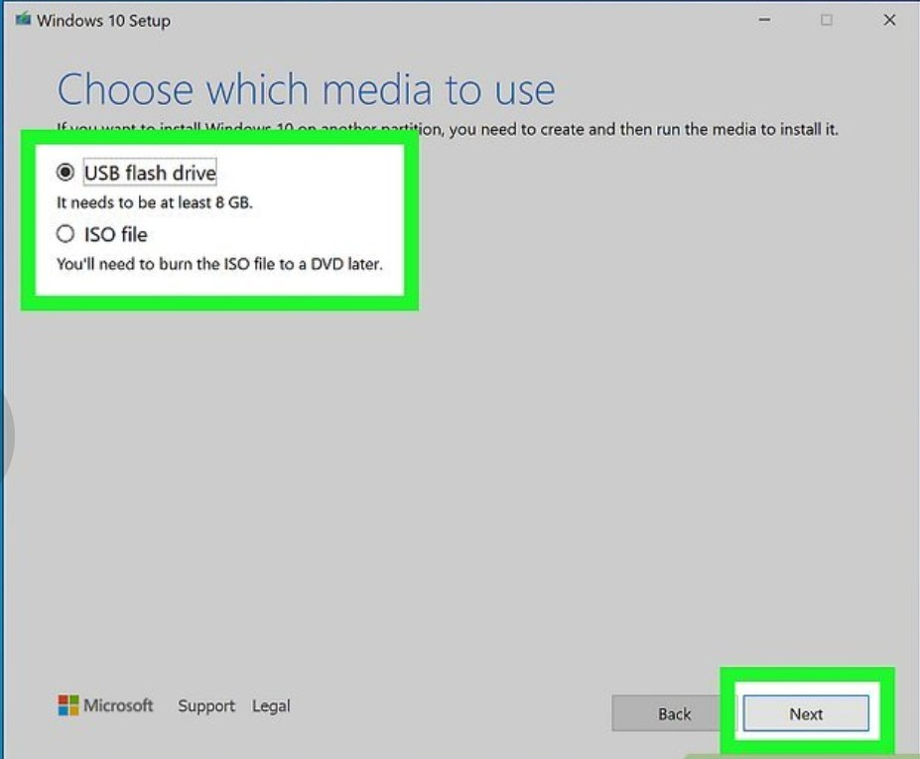STEP 9

Choose partition for installation if your computer has only one disk.

STEP 10

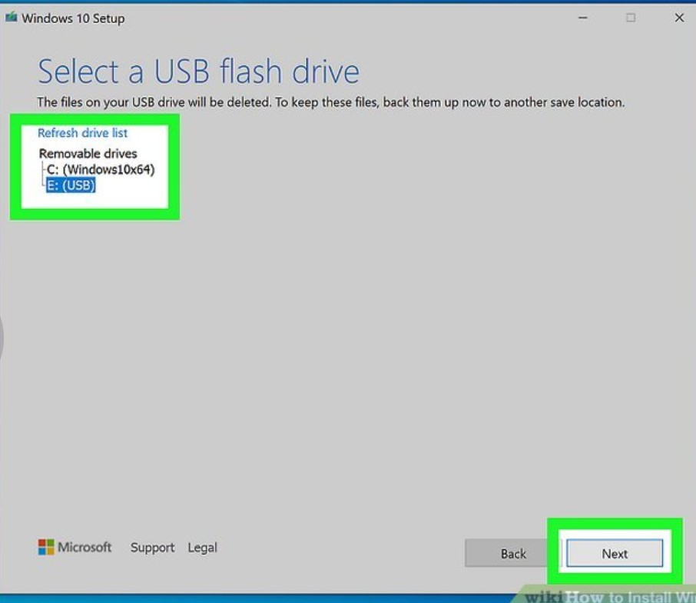

Wait for installing window to progress. You computer might need restarting during the process.

iv. explain all possible solution for your problem.

There are several possible solutions for sound problems on a computer:

* **Check connections:** Ensure all cables and connections are secure and plugged in correctly

loose connections can cause sound issues

* **Adjust volume levels:** check the volume levels on both your device and the sound output device example speakers, headphones, it’s possible that the volume may be turned down or muted
* **Update drivers:** make sure your audio drivers are up-to-date Outdated or corrupted drivers can cause sound problem. you can update drivers through device manage on windows or systems preferences on macOS.
* **Restart your device:** sometimes a simple restart can fix software-related sound issues.
* **Check sound setting:** verify that the correct audio output device is selected in your devices sound settings. Sometimes the wrong device may be selected by default.

As for the installation of a window on a computer, here are some steps to follow:

1. Purchase a copy of the Windows operating system that you want to install.

2. Backup any important files on your computer before proceeding with the installation.

3. Insert the installation disk or USB drive into your computer and restart it.

4. Follow the on-screen instructions to boot from the installation media and begin the installation process.

5. Choose the partition on which you want to install Windows and follow the prompts to complete the installation.

6. Once the installation is complete, you may need to install drivers and updates to ensure the operating system runs smoothly.

v. Device specifications

RAM 8GB

PROCESSOR 1.20GHZ

GENERATION CORE i5

STORAGE SSD256GB